


Srishyla Educational Trust®

GM UNIVERSITY
(Established under the Karnataka State Act No.19 of 2023) Post Box No.4, Davanagere - 577006

Project Based Learning Semester: I
(UE25CS1106)
PBL Report

“HEALTHCARE PATIENT PORTAL”

Section- "AI1A"

Submitted By,

ABHISHEK M PATIL – U25E01AI002
ADARSHA D S – U25E01AI003
ALSAMAD H R – U25E01AI009
CHETHAN S J – U25E01AI031

PBL Coordinator Guide

Mr. MOHAMMAD ZEESHAN M Ms. KAVYA K.N
Asst. Professor Asst. Professor
Dept. of AIML Dept. of AIML

CONTENTS

S.No. | Title | Page No.
1 | Abstract | 1
2 | Introduction | 2
3 | Problem Statement | 3
4 | Objectives | 4
5 | Methodology | 5
6 | Software Components Required | 6

1. ABSTARCT

The Healthcare Patient Portal is an innovative web-based application developed to enhance the interaction between patients and healthcare providers through digital technology. In today’s healthcare environment, effective communication, quick access to medical data, and patient engagement are vital for improving the quality of care. This portal serves as a centralized platform that enables patients to conveniently access their health information, medical history, prescriptions, lab reports, and doctor’s notes in a secure and organized manner.The system allows patients to schedule appointments, request medication refills, and consult doctors through online messaging or virtual visits, thereby reducing the need for unnecessary hospital visits and waiting times. Healthcare professionals can also update patient information, monitor progress, and share reports in real time, improving accuracy and coordination in treatment.Security and privacy are maintained through user authentication and data encryption, ensuring that sensitive medical information remains protected. The portal also includes features like health reminders, notifications, and personalized dashboards that help patients stay informed and proactive about their health management.By integrating advanced technologies and digital record systems, the Healthcare Patient Portal bridges the gap between patients and healthcare providers. It enhances transparency, reduces administrative workload, and promotes patient-centered care.

2. INTRODUCTION

The Healthcare Patient Portal is a digital platform designed to improve the interaction between patients and healthcare providers by providing secure, easy, and real-time access to health-related information. In the modern era, where technology plays a vital role in every sector, the healthcare industry is rapidly adopting digital solutions to enhance efficiency, communication, and patient satisfaction.

This portal serves as a bridge between patients and hospitals or clinics by allowing users to access their personal medical records, lab test results, prescriptions, and doctor’s notes anytime and anywhere. It eliminates the traditional paperwork system and helps maintain accurate, up-to-date medical information in one place. Patients can also book appointments, request prescription refills, and communicate with their healthcare providers through a user-friendly interface.

From a healthcare provider’s perspective, the portal simplifies patient data management, reduces administrative tasks, and improves service delivery. It ensures that doctors have immediate access to patient information, which helps in faster diagnosis and better decision-making. The system also enhances transparency and builds trust between patients and healthcare professionals.

Overall, the Healthcare Patient Portal aims to promote a more efficient, connected, and patient-centered healthcare system. By leveraging technology, it empowers patients to take an active role in their health management while supporting healthcare providers in delivering high-quality and timely care.

3. PROBLEM STATEMENT

In the traditional healthcare system, managing patient information and communication between patients and healthcare providers is often inefficient and time-consuming. Patients face challenges such as long waiting times, misplaced medical records, lack of access to their health history, and difficulty in scheduling appointments or consulting doctors remotely. Manual record-keeping also increases the chances of human error, data duplication, and information loss.
Healthcare providers struggle to maintain accurate patient data, share information quickly, and offer timely medical assistance, especially in emergency situations. The absence of a centralized digital system limits patient engagement and prevents effective monitoring of ongoing treatments Therefore, there is a need for a secure, reliable, and user-friendly online platform that allows patients to access their health records, communicate with doctors, view test results, and manage appointments conveniently. The Healthcare Patient Portal aims to solve these issues by providing a digital solution that enhances communication, accuracy, and accessibility within the healthcare system.

4. OBJECTIVES

- To provide patients with secure and easy access to their personal health records.
- To enable online appointment booking and scheduling with healthcare providers.
- To allow patients to view medical reports, prescriptions, and lab test results anytime.
- To improve communication between patients and doctors through online messaging or consultations.
- To reduce paperwork and manual record-keeping in hospitals and clinics.
- To ensure accuracy, privacy, and security of patient data through authentication and encryption.
- To enhance patient engagement and awareness in managing their health.
8.To assist healthcare providers in effiently managing patient information and treatment history.
9. To provide reminders and notifications for appointments, medications, and follow-ups.
10.To create a centralized digital system that promotes a faster, transport, and more reliable healthcare process.

5. METHODOLOGY

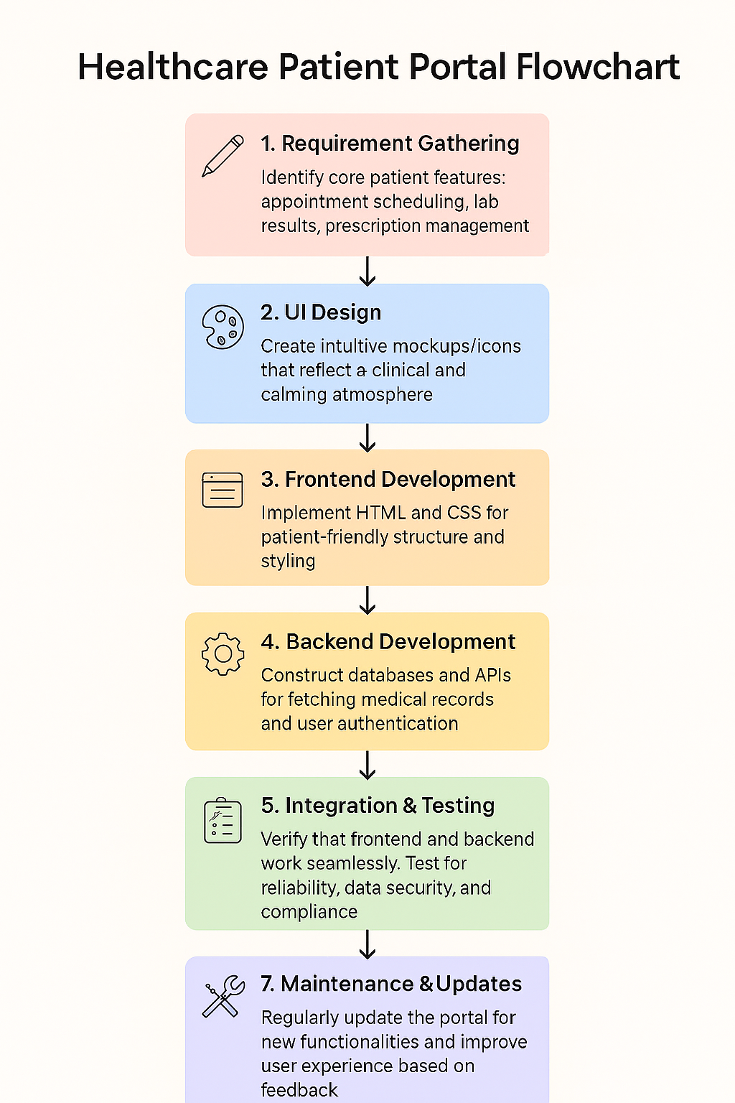

6. SOFTWARE AND HARDWARE REQUIREMENTS

Software :

- Operating System : Windows/Linux/macOS
- Frontend : HTML,CSS,JavaScript
- Backend : PHP / Python(Django or Flask) / Java(spring Boot)
- Web Server : Apache / Tomcat
- IDE/Tools : Visual Studio Code , Eclipse
- Broswer : Google Chorme / Microsoft edge.

Hardware :

- Processor : Quad core(intel Xeon / AMD)
- Ram : Minimum 16 GB(recommended 32GB or multi user acess)
- Storage : SSD 1 TB or Higher
- Network : Gigabit Ethernet or Higher
- Operating System : Windows Server
- Power Backup : UPS or inverter for continous operation.

